Army Art
Ticket Coordinator

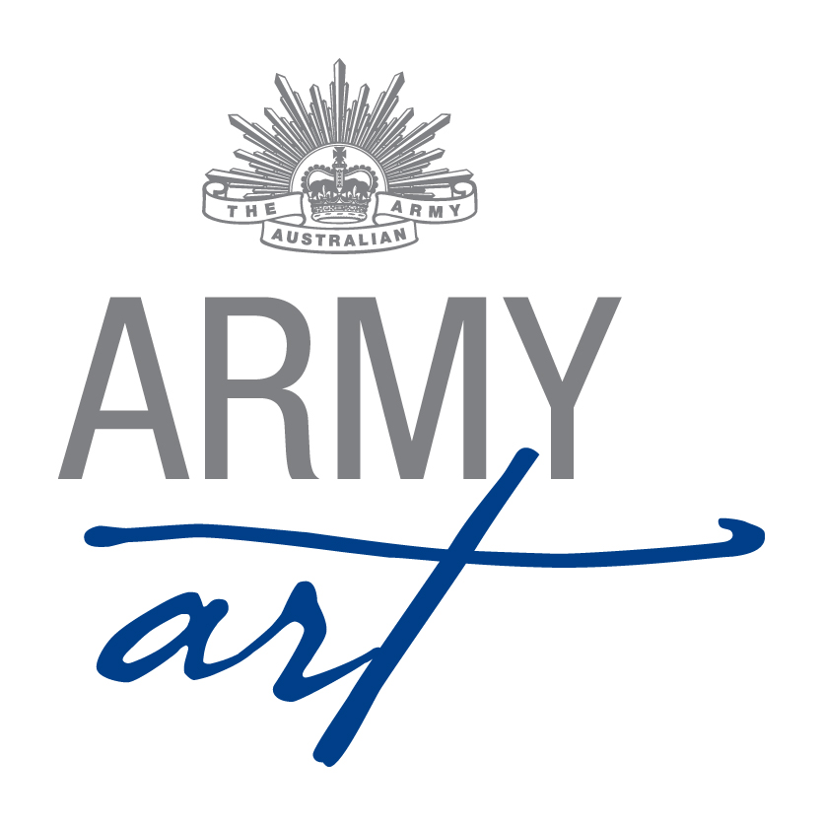
1. Position Duties and Description 2
1.1 Role 2
1.2 Skills Required 2
1.3 Meetings 2
1.4 Sequence of Events 2
Appendix A - Document Control 5
Appendix B - Sample Preliminary Email 6
Appendix C - Sample Invitation to Purchase Tickets 7
Appendix D - Sample “Ring Around” Notes 8

Position Duties and Description
A Committee member should:
- Attend monthly meetings
- Assist with the setting up of the venue (during the day and/or evening)
- Work over acceptance weekend
- Work on Opening Night
- Work over the weekend the show runs
- Assist with packing up the venue

Role
The role of the Ticketing Coordinator is to:
- Manage the sale and distribution of tickets for Opening Night
- Greet the guests at the door
- Manage charging for entry during the weekend of the show
- Enter data into the ticketing database
- Bank money received for tickets

Skills Required
To fulfil this role the following skills would be useful:
- Good organisational skills
- Approachable and sensitive to the feelings of others
- Good communication and interpersonal skills
- Flexibility
- Eye for detail
- Impartiality
- Fairness
- Respect confidences

Sub Committee/Meetings
- Sub Committees have been formed with the aim of reducing formal meeting times with each subcommittee having the power to make decisions relevant to their area without referral to the Army Art Committee
- The Ticket Coordinator along with the Catalogue and Publicity Coordinators and member of the Executive form the Marketing Sub-Committee
- Refer to Sub Committee Operational Guidelines for subcommittee meeting and decision requirements

Ensure copies of all formal letters, and relevant memos and emails are forwarded to the Secretary for recording and filing

Ensure copies of all formal letters, and relevant memos and emails are forwarded to the Secretary for recording and filing

General
- Any enquiries received are to be referred on to the relevant Coordinator – please do not second guess answers/responses/replies
- Grievances are to be dealt with privately away from the Army Art Venue, volunteers, guests and artists

Sequence of Events

Five Months Prior to Opening Night
- Review the current contact list of guests
- Send email to contact list advising the date of Army Art (use database)
- If emails are undeliverable, update the database by removing those addresses

Six Weeks Prior to Opening Night
- Update show details on Sticky Tickets website (www.stickytickets.com.au )
- Sign-in details – susan.mccalman@iinet.net.au
armyartwa
- Create New Event
- Name, suburb, phone number/mobile number and email address of attendees to be captured
- Three (3) types of tickets to be created – Opening Night tickets (price to have been determined by Committee, purchaser to pay transaction fee), Artist tickets (free) & VIP tickets (free)
- Email contact list with details of how to purchase a ticket (use database)
- Conduct “ring around” with help from other Committee members

Two Months Prior to Opening Night
The Painting and Special Exhibits Coordinators will advise how they would like their artists to receive their complimentary tickets for Opening Night (electronically or paper based)

As Requests for Tickets Arrive
- Respond to any request for tickets (record details in the database)
- Bank money/cheques regularly
- Mail tickets to those who request them to be

Day Prior to Opening Night
Set up the tables required at the entrance with:-
- Catalogues
- Visitors Book
- Comments Book for guests
- Ticket Interest form

Opening Night
- Brief ticketing volunteers on their duties
- Greet VIP guests with Chairperson and Publicity Coordinator at 6.45pm
- Open the doors at 7:00pm
- Ensure that tickets are checked
- Provide a catalogue to guests as required

Weekend of Show
Manage the payments for entry and catalogues

For the First Meeting after the Show
- Prepare a list of suggestions to improve the show and forward them to the Secretary for discussion at the meeting
- Update the database:
- Check/Add details from the Sales Books
- Add details provided in Visitors Book or on Ticket Interest form

One Month Post Opening Night
- Liaise with the Chairperson and update the Ticketing Coordinators duty statement
- Return updated folder to the Chairperson at AGM

Appendix A - Document Control
Date | Version | Sections/All | Name | Reason for Change
14/02/2011 | 1 | All | Don Maskew | Initial Document
04/03/2014 | 2 | All | Secretary | Format and standardisation of document
12/04/14 | 3 | Appendix C | Secretary | Refer Minutes 5th March 2014 – Item 6.3
20/11/20104 | 4 | 1.3, 1.4 | Secretary | Refer Minutes 19th November 2014 – Appendix A

Appendix B - Sample Preliminary Email

Hi,
Just a quick note to let you know that Army Art is on once again this year at Leeuwin Barracks, East Fremantle. Opening Night is Friday (date).
If you would like to attend Opening Night this year I suggest you put a note in your diary.
I will contact you at the end of June when Opening Night tickets will be on sale.
I look forward to seeing you at this year’s show.
Regards

Name
Ticket Coordinator
Army Art (year)
Mobile: 0498 574 637
Email: armyarttickets@hotmail.com

http://armyartwa.blogspot.com.au https://www.facebook.com/#!/ArmyArt2013

PS: If you no longer wish to be contacted by Army Art, please reply to this email with “Remove” in the Subject Field.

Appendix C - Sample Invitation to Purchase Tickets
Hi,
Army Art is on again!!!
The exhibition is again being held at Leeuwin Barracks, East Fremantle with Opening Night on Friday, (date).
Our major beneficiary this year is (name). This organisation (insert brief description of beneficiary).
As someone who has previously attended Army Art we are giving you the first opportunity to purchase Opening Night tickets.
If you would like to secure tickets for Opening Night please either:
a) Go to www.stickytickets.com.au/”tobesetup” and purchase – your tickets will be emailed to you
- Ring the Ticket Coordinator on 0498 574 637 and provide your name, address and credit card details. Your ticket, receipt and transaction slip will then be posted to you.
- Reply to this email with your postal address and EFT $30 x the number of tickets you require to:

BSB: 036 063
Account: 308082
Name: Karrakatta Community House Inc. - Army Art
Narration: T – your name
The show is also open between 10:00am and 5:00pm on Saturday, (date) and Sunday, (date) with a gold coin entry fee.
We look forward to seeing you in August.
Regards

Name
Ticket Coordinator
Army Art (year)
Mobile: 0498 574 637
Email: armyarttickets@hotmail.com

http://armyartwa.blogspot.com.au https://www.facebook.com/#!/ArmyArt2013

PS: If you no longer wish to be contacted by Army Art, please reply to this email with “Remove” in the Subject Field.

Appendix D - Sample “Ring Around” Notes

2010 Art Show
Ticket Ring Around
Hello, my name is XXXXXX and I’m calling about Army Art that is held at Leeuwin Barracks in East Fremantle. As you have previously visited the show and put your name down to be contacted, we are ringing to offer you the first opportunity to purchase Opening Night tickets. Is this a good time for me to go through what has been planned for this year’s exhibition?
If not a good time ask when a good time may be, provide the ticket mobile number or direct them to our website.
- Opening Night: Friday, August 7th
- Doors Open at: 7pm with the Official Opening commencing at 7.45pm
- Guest Opener: Name – brief run down on Guest Opener
- Tickets: $30.00
- Beneficiary: Name – brief run down on what they do
- Weekend Entry: Gold coin donation
- Saturday: 10am - 5pm
- Sunday: 10am - 3pm
Would you be interested in purchasing Opening Night tickets?
Payment Options:
- A cheque or money order for the total amount made out to Army Art and sent to (address) along with a stamped, self-addressed envelope for the return of the tickets
- Credit/Debit Card over the telephone now
- Otherwise you can EFT payment to:
- BSB 036 063
Account: 308082
Name: Karrakatta Community House Inc. – Army Art
Narration – T – name
- Make sure address to send tickets to is recorded and confirm other details held are correct
The last mail out for tickets will be Tuesday 4th August or earlier if sold out - tickets will not be mailed out after this date.
Any queries contact the Ticket Coordinator on 0498 574 637.
If no tickets are required this year, ask if they would like their name to remain on the database for next year.
Thank you for your time it is very much appreciated and we look forward to seeing you on Opening Night.

