Army Art
Treasurer

1. Position Duties and Description 2
1.1 Role 2
1.2 Skills Required 2
1.3 Meetings 2
1.4 Duties 2
1.5 Sequence of Events 3
Appendix A - Document Control 6
Appendix B - Re-Imbursement Voucher 7
Appendix C - Sample Exhibitors Payment Report 8
Appendix D - Opening Night Brief for Sales Tables 9

Position Duties and Description
A Committee member should:
- Attend monthly meetings
- Assist with the setting up of the venue (during the day and/or evening)
- Work over acceptance weekend
- Work on Opening Night
- Work over the weekend of the show
- Assist with packing up the venue

Role
The role of the Treasurer is to
- maintain the accounts in accordance with accounting regulations
- ensure the organisation has the correct financial policies and procedures in place
- report the financial position to Committee meetings

Skills Required
To fulfil this role the following skills would be useful:
- Good organisational skills
- Approachable and sensitive to the feelings of others
- Good communication and interpersonal skills
- Flexibility
- Eye for detail
- Impartiality
- Fairness
- Respect confidences
A financial background would be an advantage for this position.

Sub-Committees/Meetings
- Sub Committees have been formed with the aim of reducing formal meeting times with each subcommittee having the power to make decisions relevant to their area without referral to the Army Art Committee
- At least one member of the Executive must serve on each sub-committee
- Refer to Sub-Committee Operational Guidelines for subcommittee meeting and decision requirements
- Prepare a report for each Committee meeting.
- An electronic copy of the report should be forwarded to the Secretary for distribution to the Committee no later than 2 days before the meeting
- The report should include any items to be discussed and any proposals that will be made at the meeting
- Ensure copies of all formal letters, and relevant memos and emails are forwarded to the Secretary for recording and filing

Duties
- The Treasurer is responsible for Army Art’s finances and budget and is to ensure that:
- Adequate books of accounts are kept
- The books are audited at least annually
- The Committee receive adequate financial advice
- Petty cash is managed
- EFTPOS machines for the show are supplied and managed
- Floats for the duration of the show are maintained

General
- Any enquiries received are to be referred on to the relevant Coordinator – please do not second guess answers/responses/replies
- Grievances are to be dealt with privately away from the Army Art Venue, volunteers, guests and artists

Sequence of Events

Immediately After Appointment
Update the signatories to the bank account as per the Rules of Management

Six Months Prior to Opening Night
Make arrangements for the supply of seven (7) EFTPOS machines. These shall be obtained through the bank or financial institution used by Army Art. They need to be set up for MOTO and settle at 11:30pm WA.

Three Months Prior to Opening Night
- Provide receipt books to:
- Ticket Coordinator
- Painting Coordinator
- Special Exhibits Coordinator
- Provide bank deposit slips to the Ticket Coordinator

Six Weeks Prior to Opening Night
One EFTPOS machine to be delivered prior to the start of ticket sales

Two Weeks Prior to Opening Night
- Ensure there are sufficient receipt books (stamped with Army Art stamp) for the show
- Set up office in conjunction with Venue Coordinator
- Arrange for petty cash to be available during set up of Drill Hall. If the Treasurer is not on site every day, this task is to be handled by the Chairperson.
- Organise a float for Acceptance Day (about $500.00, discuss with Committee)
- Organise a float for Opening Night (about $3,500.00, discuss with Committee)

One Week Prior to Opening Night
Six EFTPOS machines to be delivered no later than the Monday before Opening Night

Opening Night
- Prior to doors opening:
- Check EFTPOS machines are logged in
- Distribute cash tins containing float and EFTPOS machines to the sales tables
    - After Doors Close:
- Total all sales. The total is to be given to the Chairperson who will announce it at the Post Event Supper. The figure is not to be given to any other person.
- Secure all monies
- Secure the EFTPOS machines

1.5.9 Weekend of Show
- Total the door receipts at the end of Saturday and Sunday
- Saturday
- Put the floats for sales tables and the door sales into cash tins and distribute along with EFTPOS machines
- Check that:
- All EFTPOS slips from Opening Night have a receipt number on them
- All receipts have the item numbers recorded on them
- The receipt number has been entered against all items sold in the sales books
- Sales are being recorded correctly
- During the day total and check sales for Opening Night, break down by item category (eg. Painting, Special Exhibits)
- After doors close secure all monies and EFTPOS machines
- Sunday
- Put the floats for sales tables and door sales into cash tins and distribute along with EFTPOS machines
- Total and check sales for Saturday, break down by item category (eg. Painting, Special Exhibits)
- Check that sales are being recorded correctly
- After doors close secure all monies and EFTPOS machines

Immediately After the Show
- Bank all monies
- Return the EFTPOS machines as directed by the bank
- Reconcile all transactions for the show

Two Weeks Post Opening Night
- Prepare payments for the exhibitors whose work was sold. Liaise with the Catalogue Coordinator for payment listing (cross check the data provided) and envelopes
- Chairperson to countersign cheques and post along with letter thanking artist for exhibiting and giving them details of the final sales figures.

For the First Meeting after the Show
- Prepare a list of suggestions to improve the show and forward them to the Secretary for discussion at the meeting
- Prepare the cheques for each of the individual and corporate beneficiaries and present them to the Chairperson for signature

One Month Post Opening Night
- Liaise with the Chairperson and update the Treasurer’s duty statement
- Return updated folder to the Chairperson at AGM

After all Financial Issues Finalised
- Once all financial issues have been finalised following show arrange for the books to be audited.
- After completion of audit financial records to be packed up and stored

Document Control
Date | Version | Sections/All | Name | Reason for Change
12/02/2011 | 1 | All | Don Maskew | Initial Document
20/02/2014 | 2 | All | Secretary | Format & standardisation of Document
20/11/2014 | 3 | 1.3 | Secretary | Refer Minutes 19th November 2014 – Action List

Sample Re-Imbursement Voucher
REQUEST FOR PAYMENT FORM

Date: |  |  | Required by:
Payable to:
Amount: |  | $
For:

Method of payment:

Cheque No: |  | Petty Cash:

Documentation attached: | Yes / No
Authorised – Minutes of:

Sample Exhibitors Payment Report
This is a sample report from the database
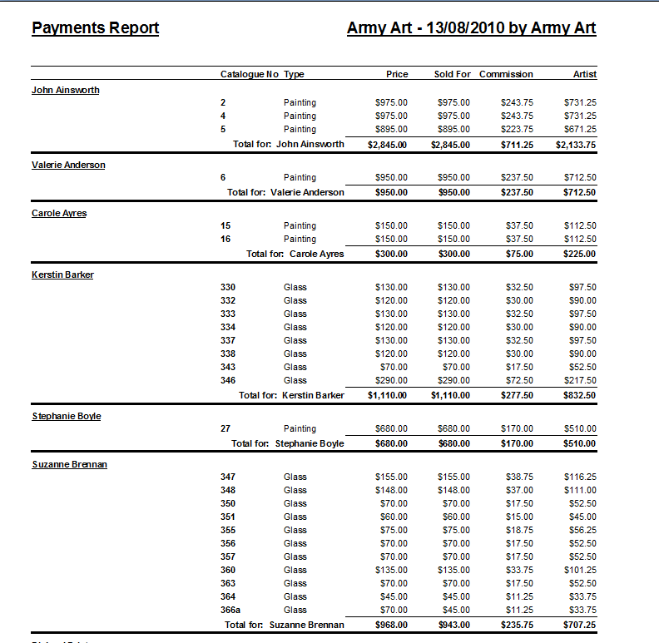

Sample Opening Night Brief for Sales Tables

BRIEF FOR SALES TABLES
- If a purchaser approaches the table without a Red Dot person, call one so they can put the red dot on the item.
- Draw a line through the item in the sales book
- The purchaser’s name (please try and note Christian name for ease of contact next year), contact phone number and email (if possible) will then be noted in the sales book. Ask if they would like to be contacted for tickets to Opening Night next year. The email address may be used for this purpose.
Payment
Please take your time and complete the transaction properly. It is very important for our financial records and to ensure the purchaser has the correct item.
Payment may be made by cash, cheque, EFTPOS, Bankcard, Mastercard or Visa. Please note the method of payment in the Sales Book for ease of reconciling.
Cheques are to be made payable to Army Art. There is no need for details to be written on the back of the cheque as we will have them in the Sales Book.
If the purchaser is making payment by Cash or Cheque, a receipt is written out and the receipt number noted in the Sales Book.
If the purchase is to be made using a card, process the transaction and then write the receipt once the transaction has been approved. Write the receipt number in the Sales Book and on our copy of the transaction record. Put in relevant cash box. The purchaser’s copy of the transaction record is to be attached to their receipt.
Write the purchasers details on the right hand page of the sales book
Advise purchaser of pick-up time – Sunday between 3pm and 4pm. This is also noted in the catalogue. Items will not be released prior to this time. Receipts must be shown for purchase to be released.
Deposits
A purchaser may place a 25% deposit on an item for it to be held. Details of payment are:
Deposit paid | Balance to be paid
Opening night | By 11.00am Saturday morning
Saturday | Within 3 hours of deposit being made
Sunday | By 3.00pm
Credit card details can be rung through for payment of balance.

Please highlight deposits in Sales Books so that they can be followed up
Post Event Supper
A light supper and drinks will be available for all volunteers once all guests have left and doors are closed.
Name tags
Please wear your name tag prominently during the night. Upon doors closing please return the tag to the basket for your chance to win a prize at the Post Event Supper.

