Army Art
Catering Coordinator

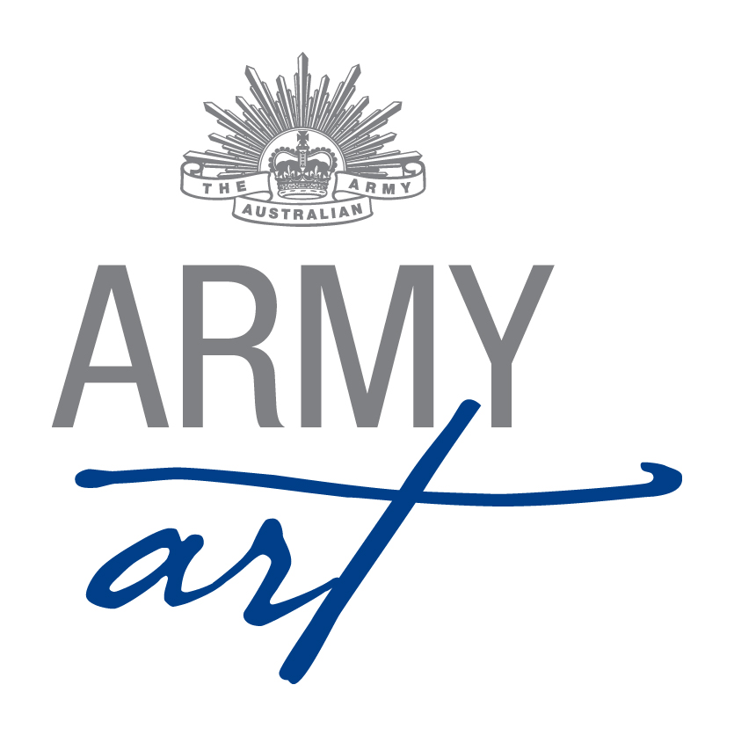
1. Position Duties and Description 2
1.1 Role 2
1.2 Skills Required 2
1.3 Meeting 2
1.4 Sequence of Events 3
Appendix A - Document Control 5
Appendix B - Sample Menu 6
Appendix C - Catering Inventory 7
Appendix D - Opening Night Brief 8

Position Duties and Description
A Committee member should:
- Attend monthly meetings
- Assist with the setting up of the venue (during the day and/or evening)
- Work over acceptance weekend
- Work on Opening Night
- Work over the weekend of the show
- Assist with packing up the venue

Role
The role of the Catering Coordinator is to manage the provision and delivery of food, wine and beverages for Army Art. This includes:
- Preparing a suggested menu, in consultation with the Committee
- Obtaining quotes/donations for the supply of the food, wine and beverages
- Accepting a quote for the menu, in consultation with the Committee
- Liaising with suppliers
- Advising the Volunteer Coordinator how many volunteers will be required and what their roles they will fulfil
- Managing the catering team during Opening Night
- Providing food and drinks for the band
- Providing food for the Post Event Supper
- Setting up tea and coffee facilities for guests over the weekend

Skills Required
To fulfil this role the following skills would be useful:
- Good organisational skills
- Approachable and sensitive to the feelings of others
- Good communication and interpersonal skills
- Flexibility
- Eye for detail
- Impartiality
- Fairness
- Respect confidences

Sub Committee/Meetings
- Sub Committees have been formed with the aim of reducing formal meeting times with each subcommittee having the power to make decisions relevant to their area without referral to the Army Art Committee
- The Catering Coordinator along with the Venue and Volunteer Coordinators and member of the Executive forms the Hospitality Sub-Committee
- Refer to Sub Committee Operational Guidelines for subcommittee meeting and decision requirements

Ensure copies of all formal letters, and relevant memos and emails are forwarded to the Secretary for recording and filing

Ensure copies of all formal letters, and relevant memos and emails are forwarded to the Secretary for recording and filing

General
- Any enquiries received are to be referred on to the relevant Coordinator – please do not second guess answers/responses/replies
- Grievances are to be dealt with privately away from the Army Art Venue, volunteers, guests and artists

Sequence of Events

1.5.1 Upon finalisation of Opening Night date

Letters to be sent to Coles, Woolworths, IGA etc asking for food donations for catering purposes

Five Months Prior to Opening Night
- Prepare a proposed menu and a list of wine and beverage requirements
- Obtain quotes and donations of the food, wine and beverages, as appropriate
- Present the list of proposed menu, wine and beverages to the Committee

Four Months Prior to Opening Night
- Seek quotes from two or three caterers for the creation and delivery of the food (not the distribution during the show)
- Present the quotes to the Committee with a recommendation on which to select
- Prepare a letter for the Chairperson to send to the successful caterer

One Month Prior to Opening Night
- Liaise with the caterer and suppliers to ensure they have all the information they require to provide the food, wine and beverages
- Ensure a meal has been organised for the band on Opening Night

Two Weeks Prior to Opening Night
- Liaise with the Volunteer Coordinator to ensure the catering teams are adequately staffed and that the Team Leader for beverages is an Approved Manager for the Responsible Service of Alcohol
- Review the Guidelines for Catering Staff for Opening Night and make any necessary amendments
- Liaise with the Venue Coordinator about when the catering areas can be set up in the Drill Hall/Café
- Arrange for the washing and pressing of all the linen (eg. aprons, tea towels, etc) for the catering staff to use on Opening Night
- Provide a list of donors/sponsors with logos to the Catalogue Coordinator for inclusion in catalogue and PowerPoint presentation

One Week Prior to Opening Night
- Designate the Wednesday prior to Opening Night, if available, as the day for all deliveries to be made and arrange the delivery and/or pick up of wine and beverages, banners and promotional material of the suppliers and caterers
- Arrange for the appropriate storage of the wine and beverages
- Arrange for the washing of wine glasses, platters and any other equipment required
- Arrange delivery of platters to caterer, if appropriate

Opening Night
- In the morning set up the wine and beverages area and set up areas ready to receive the food
- Position the wine and beverages ready for Opening Night (may need help of volunteers)
- Be available to receive food when it is delivered by the caterer (will need help of volunteers)
- Arrange for beverages (and glasses) to be in south end of hall for Army Band
- Arrange for water jugs and tumblers on sales tables at beginning of evening
- Brief the catering volunteers and provide document titled “Guidelines for Catering Staff”
- Oversee the service of the food, wine and beverages
- Manage the clean up of the catering areas after the end of the service of the food
- After doors close, arrange for the set up of the food, wine and hot water urn for coffee and tea for the Post Event Supper
- All volunteers to assist with clean up after supper, ready for Saturday opening

Weekend of Show
- Set up tea and coffee for the guests
- Assist with the manning of the art show venue over the weekend
- By mid day on Sunday:
- Clean all areas used by the catering team
- Update the inventory of equipment
- Itemise any items broken or lost that need to be replaced
- Wash and pack away stores - ensure that storage boxes are labelled top & side with area used in, contents of box and where it is to be placed during set up the following year
- All Wine Table tablecloths (14) and Oblong Table tablecloths (6) to be removed and placed in one container for Venue Coordinator to wash
- Plastic from wine tables to be clipped to black cardboard and placed flat in container

For the first Meeting after the Show
Prepare a list of suggestions to improve the show and forward to the Secretary for discussion at the meeting

One Month Post Opening Night
- Liaise with the Chairperson and update the Catering Coordinators duty statement and inventory
- Return updated folder to the Chairperson at AGM

Document Control
Date | Version | Sections/All | Name | Reason for Change
06/02/2011 | 1 | All | Don Maskew | Initial Document
21/02/2014 | 2 | All | Secretary | Format & standardisation of document
20/11/2014 | 3 | 1.1, 1.3, 1.4 | Secretary | Refer Minutes 19th November 2014 – Action List

Sample Menu

Sample List of Wine and Beverages Requirements

Item | Quantity | Supplier | Comments
White wine | 10 cases | Howling Wolves | Current Supplier
Red wine | 12 cases | Howling Wolves | Current Supplier
Sparkling White | 2 cases | Howling Wolves | Current Supplier
Orange Juice |  | Harvey Fresh | Current Supplier
Apple Juice |  | Harvey Fresh | Current Supplier

Catering Inventory
Item | Number | Location/Source |  | Comments
Aprons |  | Army Art Storeroom
Tea Towels |  | Army Art Storeroom
Platters silver | 10 | Army Art Storeroom
Platters white | 63 | Army Art Storeroom
Plastic Containers | 4 | Army Art Storeroom
Dip Dishes white - large | 9 | Army Art Storeroom
Dip Dishes white - medium | 5 | Army Art Storeroom
Dip Dishes glass | 5 | Army Art Storeroom
Dip Dishes crinkle | 4 | Army Art Storeroom
Dishes Small white | 4 | Army Art Storeroom
Table Cloths white | 10 | Army Art Storeroom
Toothpicks |  | Army Art Storeroom |  | Lots
HD Rubbish Bags | 3 pkts | Army Art Storeroom
Doilies – assorted sizes |  | Army Art Storeroom |  | Lots
Gloves medium | 1 box | Army Art Storeroom
Gladwrap | 1 box | Army Art Storeroom
Serviettes | 16 pkts | Army Art Storeroom |  | 50/pkts
Pate Knife | 10 | Army Art Storeroom
T Shirts |  |  | Army Art Storeroom
Glasses |  |  | Army Art Storeroom
Trunks |  |  | Leeuwin Barracks
FS Tables |  |  | Leeuwin Barracks
Wine Tables |  |  | Army Art Storeroom
Waiters Friends | 4 |  | Army Art Storeroom
Bottle Opener/Corkscrew | 6 |  | Army Art Storeroom
Stanley Knife | 2 |  | Army Art Storeroom
Wine Table tablecloths | 14
Oblong tablecloths | 6

Sample Opening Night Brief
GUIDELINES FOR CATERING STAFF
Thank you for volunteering to help with catering tonight. Your help is greatly appreciated and valued.
Here are a few key things you will need to know:
- There are three team leaders – one at each station from which food or beverages will be served.
- If you have any queries please speak to the Catering Coordinator who will coordinate the three stations.
Timing
Your team will be required to serve food or beverages from 7pm until 9pm.
Platters/Stations
- Some platters will be placed at the end of the painting screens for guests to help themselves. Please remember to remove empty platters and replace them with full ones on an as needs basis.
- When taking out a new platter please begin round from where you last served in order that all guests can avail themselves to the food.
Menus
Menus will be on display in both sections and it is very important that you familiarise yourself with them in order to answer any dietary questions from the guests
Hot and Cold Food
Between 7pm and 8pm the platters being served will consist of cold food. From 8pm onwards the platters will consist of warm food. (Adjust as required).
Serving and Promoting the Wine
  - The wine has been substantially subsidised by Howling Wolves. It is therefore important that we serve and promote the wine in the best way possible. Please take the time to study the laminated wine information sheets so that you can readily inform our guests about the wonderful wine Howling Wolves have provided.
  - Under no circumstances should guests be given a wine bottle to serve themselves.
  - Do not serve obviously intoxicated guests.
  - Do not serve volunteers with wine until doors are closed
Non-alcoholic Drinks
Water is available from the water cooler. Orange juice will be available from the bar.

Glasses and empty bottles
- Clean glasses will be available from the bar.
- Please try and encourage our guests to retain their wine glass… unless of course they insist or are changing their choice of wine
- Empty bottles and used glasses should be gathered whenever practical and returned to the main bar area
Food and drinks for volunteers
- Please remember that the food and drink are for our Opening Night guests.
- Supper and drinks will be provided after the doors have closed
Spillages/Breakages
- Any accidental spillages or breakages should firstly be clearly marked with hazard signs and cleaned up with the broom and mop available from:
- In the little room leading to the men’s toilet
- In the sick room
- In the wine service area
- Please return this equipment back to the cleaning station when you have finished the clean up
- In the event of injury please escort injured to First Aid Room (denoted by white posts and First Aid sign) which is located near the dais (river side wall).
Promotional clothing
- The beverages team will be provided with a Howling Wolves t-shirt and apron to wear for the duration of the night. Please sign for these items and ensure you hand them back to the Catering Coordinator at the conclusion of the evening.
Post Event Supper
A light supper and drinks will be available for all volunteers once all guests have left and doors are closed.
Name Badges
Please wear your name badge prominently during the night. Upon doors closing please return the badge to the basket for your chance to win a prize at the Post Event Supper.

Smile and enjoy yourself
It is a great night for all

