Army Art
Secretary

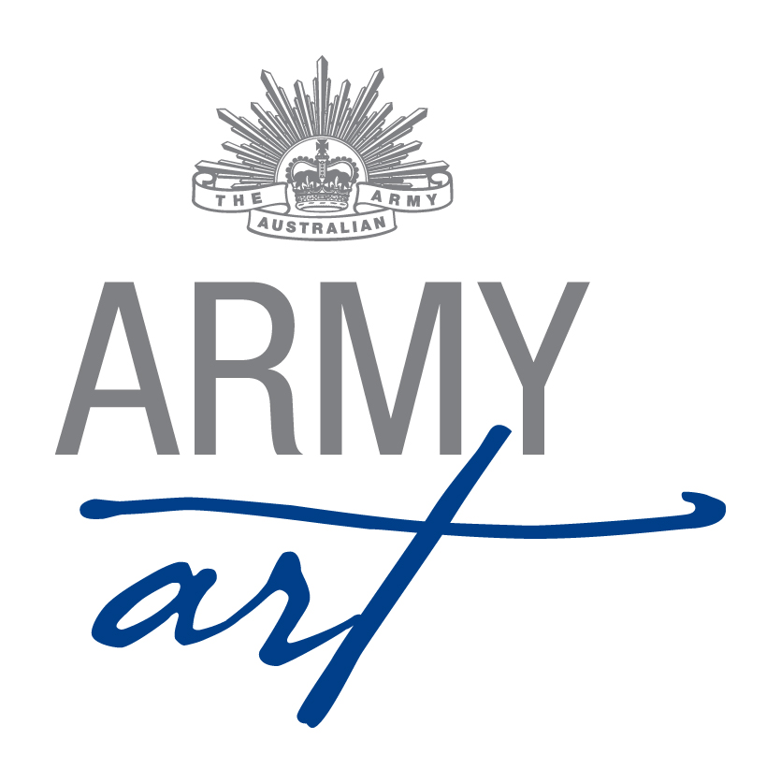
1. Position Duties and Description 2
1.1 Role 2
1.2 Skills Required 2
1.3 Meetings 2
Appendix A - Document Control 4

Position Duties and Description
A Committee member should:
- Attend monthly meetings
- Assist with the setting up of the venue (during the day and/or evening)
- Work over acceptance weekend
- Work on opening night
- Work over the weekend of the show
- Assist with packing up the venue

Role
The role of the Secretary is to support the administration of the organisation and facilitate and support Committee meetings by preparing and distributing required documentation.

Skills Required
To fulfil this role the following skills would be useful:
- Good organisational skills
- Word processing skills
- Approachable and sensitive to the feelings of others
- Good communication and interpersonal skills
- Flexibility
- Eye for detail
- Impartiality
- Fairness
- Respect confidences

Meetings

General
- Be responsible for maintaining a history of Army Art in conjunction with the Chairperson.
- Maintain the originals of the following documents:
- Rules of Management
- Guidelines for the Operation of Army Art
- Committee Duty Statements

Before Meetings
- Request items for the agenda from all Committee members including all correspondence to be recorded
- Discuss the agenda with the Chairperson
- Prepare the agenda
- Prepare an Action List based on previous minutes
- Distribute documentation required for meetings to Committee members 1 day prior to meeting

During Meetings
- Check a quorum is present
- Take accurate minutes of the meeting
- Present record of sub-committee meetings and decisions to Army Art Committee
- Ensure the previous meeting’s minutes are signed by the Chairperson, once they have been ratified by the meeting.

Following Meetings
- Prepare the draft minutes
- Submit the draft minutes to the Chairperson for approval
- Distribute the minutes to all Committee members
- Copy of minutes to be sent to the Leeuwin Barracks Liaison
- Carry out any tasks assigned to the Secretary

General
- Ensure an up to date record of members of the organisation is maintained
- File copies of all documents produced by the organisation
- Any other duties as requested by the Chairperson

Sub-Committees
- At least one member of the Executive must serve on each sub-committee
- Refer to Sub-Committee Operational Guidelines for subcommittee meeting and decision requirements
  - General
- Any enquiries received are to be referred on to the relevant Coordinator – please do not second guess answers/responses/replies
- Any grievances are to be dealt with privately away from the Army Art venue, volunteers, guests and artists
  - Sequence of Events

One Month Prior to Opening Night
Provide Catalogue Coordinator with the following Guidelines for inclusion in sales books:-
- Guidelines for Receiving Paintings
- Guidelines for Receiving Special Exhibits
- Guidelines for Sales Tables
- Guidelines for Purchases by Volunteers
- Guidelines for Picking Up Paintings
- Guidelines for Picking Up Special Exhibits

Two Weeks Prior to Opening Night
- Print out and photocopy the following Guidelines for Acceptance Weekend:-
- How to Hang Paintings
- Guidelines for Displaying Special Exhibits

One Week Prior to Opening Night
- Print out and photocopy the following Guidelines for Opening Night:-
- Guidelines for Catering Staff
- Guidelines for Red Dot Runners
- Prepare contact sheet for people enquiring about next year’s exhibition

Weekend of Show
Assist with the manning of the art show venue over the weekend

For the First Meeting after the Show
Prepare a list of suggestions to improve the show

One Month Post Opening Night
- Liaise with the Chairperson and update the Secretary’s duty statement
- Return updated folder to the Chairperson at AGM

Prior to AGM
- Prepare Notice of Annual General Meeting with Explanatory Statement, Proxy Form and Nomination Form included
- Send Notice of AGM to existing Committee Members, all volunteers, sponsorship representatives and the current beneficiary representative
- Prepare package for distribution at AGM which includes:
- Notice of Annual General Meeting
- Previous AGM Minutes
- Chairperson’s Report
- Treasurer’s Report
- Nomination Forms

Document Control
Date | Version | Sections/All | Name | Reason for Change
03/02/2011 | 1 | All | Don Maskew | Initial Document
20/02/2014 | 2 | All | Secretary | Format and standardisation of document
20/11/2014 | 3 | 1.3, 1.4 | Secretary | Refer Minutes 19th November 2014 – Action List

