Army Art
Special Exhibits Coordinator

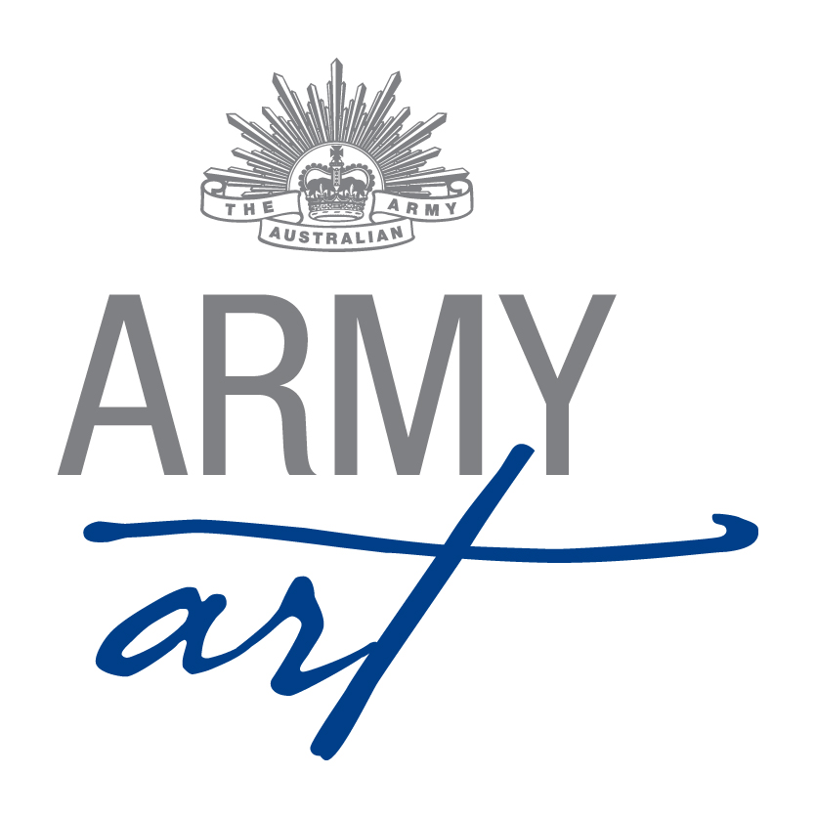
1. Position Duties and Description 2
1.1 Role 2
1.2 Skills Required 2
1.3 Meetings 2
1.4 Sequence of Events 3
Appendix A - Document Control 7
Appendix B - Sample Conditions of Entry 8
Appendix C - Sample Special Exhibits Entry Form 10
Appendix D - Acceptance Day Guidelines 12
Appendix E - Guidelines for Displaying Special Exhibits 14
Appendix F - Opening Night Brief for Sales Tables 16
Appendix G - Guidelines for Picking Up Special Exhibits 18
Appendix H - Receipt of Work Form 19
Appendix I - Guideline for purchases by Volunteers 20

Position Duties and Description
A Committee member should:
- Attend monthly meetings
- Assist with the setting up of the venue (during the day and/or evening)
- Work over acceptance weekend
- Work on Opening Night
- Work over the weekend the show runs
- Assist with packing up the venue

Role
The Special Exhibits Coordinator manages the:
- Selection of artists to exhibit special exhibits
- Invitation of the artists to exhibit
- Receipt of entry forms
- Receipt of items to be exhibited
- Display of the artists’ work
- Sales of special exhibits items
- Pick up of sold and unsold items

Skills Required
To fulfil this role the following skills would be useful:
- Good organisational skills
- Approachable and sensitive to the feelings of others
- Good communication and interpersonal skills
- Flexibility
- Eye for detail
- Impartiality
- Fairness
- Respect confidences

Sub Committee/Meetings
- Sub Committees have been formed with the aim of reducing formal meeting times with each subcommittee having the power to make decisions relevant to their area without referral to the Army Art Committee
- The Special Exhibits Coordinator along with the Painting, Venue and Volunteer Coordinators and member of the Executive forms the Display Sub-Committee
- Refer to Sub Committee Operational Guidelines for subcommittee meeting and decision requirements
- Ensure copies of all formal letters, and relevant memos and emails are forwarded to the Secretary for recording and filing
  - General
- Any enquiries received are to be referred on to the relevant Coordinator – please do not second guess answers/responses/replies
- Any grievances are to be dealt with privately away from the Army Art venue, volunteers, guests and artists

Sequence of Events

From Appointment
- Discuss with the Committee the type of work that is to be exhibited
- Catalogue Coordinator to provide list of artists who exhibited at the previous art show – review sales ie. look at percentage sold etc
- Return list to Catalogue Coordinator with each artist marked as:
- Invite; or
- Past (not to be invited ever again); and
- Add details of new artists (Name, address, phone number, email, etc.) The web site www.AusGlass.org.au may be of assistance
- Try to identify about 20% new artists each year

Five Months Prior to Opening Night
- Discuss with the Committee the number of items per artist, number of artists, entry fee, etc
- Arrange with Committee members to visit galleries/studios to view potential artists’ work and to provide recommendations.
- Finalise list of artists to be invited. Identify extra artists in the event an invited artist declines
- Review the following forms in conjunction with the Chairperson and Painting Coordinators
- Conditions of Entry
- Entry forms for Painting and Special Exhibits
- Present amended forms to the Committee for approval
- Make informal contact with the artists to find out whether they would like to exhibit this year and advise that a formal invitation will be sent out shortly. Discuss the pricing of entries the Committee is looking for, based on past years entries in the $200 - $2000 range typically sell.

Three Months Prior to Opening Night
- Send out entry forms and conditions of entry to the selected artists. If this is the first time an artist has been invited include a letter outlining the aims of the art show
- Get a receipt book from the Treasurer to receipt entry money
- Discuss the number of volunteers required for set up, Opening Night, over the weekend and for pack up with the Volunteer Coordinator

As Entries Arrive
- Ensure that the entry complies with the Conditions of Entry and discuss with the artist if form is non-compliant
- Upon receipt of monies, complete the Office Use Only section on the Entry Form
- If an artist pays via EFT notify the Treasurer payment is to be made. Once fees identified in Army Art’s account a receipt can be issued.
- Upon receipt of Entry Form scan copy through to the Catalogue Coordinator
- File Entry Forms in alphabetical order
- Provide details of artists who are willing to promote Army Art to the Publicity Coordinator and suggest which artists may be the best to be used

Two Months Prior to Opening Night
Ticketing Coordinator will provide artists’ complimentary tickets with EXHIBITOR stamped on back once printed

Three Weeks Prior to Opening Night (Entry Cut Off)
- Review the number of items entered
- Follow up artists who have not responded
- If entry numbers down, invitation to exhibit to be sent to standby artists
- Confirm with Volunteer Coordinator the number of volunteers available for Special Exhibits

Two Weeks Prior to Opening Night
- Proof read the sales book and advise the Catalogue Coordinator of any corrections required
- Write out the special exhibits number dots for all art works (from the sales books)
- Put complimentary tickets (ensure they are stamped Exhibitor on back) in an envelope for the artist to collect on Acceptance Day
- Clip the entry numbers and envelope with tickets to the sales book on the entry for the artist

One Week Prior to Opening Night
- By Thursday night, tables and screens should be set up for Special Exhibits by Venue Coordinator (liaise with Chairperson, Painting and Venue Coordinators). Tables to be individually skirted to allow for easy adjustment of table
- Tables for sales books to be set up for Acceptance Day with the following:
- White tablecloth on sales tables
- Relevant Sales Book
- Red pen
- Blue pen
- Pencil
- Ruler
- White Out
- Numbers relating to book
- Envelopes with the artists’ receipt and complimentary ticket
- Receipt of Works form (to be given to artist)
- Blue Tack
- A rubbish bin (behind tables)
- Place sales book number and letter range on wall behind table in line with book

Acceptance Day
- Brief the Special Exhibits volunteers on what is required of them on Acceptance Day
- Provide volunteers with document titled “Guidelines for Receiving Special Exhibits”
- Manage the delivery of the Special Exhibits pieces
- Provide Catalogue Coordinator with any changes made to entries during delivery

Display Special Exhibits
- Brief volunteers and provide them with document titled “Guidelines for Displaying Special Exhibits”
- Display Special Exhibits according to procedures

Day Prior to Opening Night
- Email to be sent to all artists reminding them that Army Art is ready to open and that any unsold pieces have to be collected on Sunday between 4pm and 5pm
- Set up Special Exhibits sales tables as follows:
- Sales Book
- Receipt Book (make sure when to pick up is stamped on the back of receipts)
- Two red pens
- Two blue pens
- Ruler
- Stapler (and extra staples)
- Water glasses
- Stick reduced copy of the relevant part of the catalogue in front of each book
- Rubbish bin
- A copy of the catalogue
    - Opening Night
- Hand a copy of the “Guidelines for Sales Tables” to each volunteer as they arrive
- Brief Special Exhibits sales book volunteers on their duties
- Treasurer will deliver cash tin and ensure EFTPOS machines are functioning prior to doors opening
- Manage the sale of Special Exhibits
- At the end of the night ask Special Exhibits volunteers to add up the sales in each book and provide final figures to Treasurer

Weekend of Show
- Prior to doors opening on Saturday and Sunday morning check the sales books against the red dots on the items and resolve any discrepancies
- Mark a catalogue with the daily sales in different colours (for future reference)
- Manage the Special Exhibits sales

Sunday Pick-up
- Prepare for the pick up of purchases and unsold items – move wine tables to area near Special Exhibits display and have wrapping material available
- Remove any unnecessary items on sales table and each book should have:
- Red pen
- Blue pen
- Ruler
- Receipt book
- Cash tin
- EFTPOS machine
- Extra paper
- Brief the Special Exhibits volunteers on their duties and have them read the “Guidelines for Picking Up Special Exhibits” (at back of sales book)
- If any purchases or unsold items are left at the end of pick up contact the appropriate person to arrange collection of items

Sunday After Pick-Up Complete
- Ask Special Exhibits volunteers move any unclaimed items to one table
- Pack stationery into containers and place into office
- All FS Table white tablecloths and calico covers to be removed and placed into one container for Venue Coordinator to wash

Monday Post Show
- Pack items and ensure that storage boxes are labelled top & side with area used in, contents of box and where it is to be placed during set up the following year
- Place at north west end of hall for the Venue Coordinator to pack storeroom
- Note any items that need replacing or repair

For the First Meeting after the Show
Prepare a list of suggestions to improve the show and forward them to the Secretary for discussion at the meeting

One Month Post Opening Night
- Liaise with the Chairperson and update the Special Exhibits Coordinators duty statement and inventory
- Return updated folder to the Chairperson at AGM

Document Control
Date | Version | Sections/All | Name | Reason for Change
06/02/2011 | 1 | All | Don Maskew | Initial Document
01/01/2014 | 2 | All | Secretary | Format & standardisation of document
12/04/14 | 3 | 1.4 | Secretary | Refer Minutes 5th March 2014 – Item 6.3
19/11/14 | 4 | 1.3, 1.4, Appendix B – E, G & H | Secretary | Refer Minutes 19th November 2014 – Action List

Sample Conditions of Entry

Sample Special Exhibits Entry Form

Sample Acceptance Day Guidelines
GUIDELINES FOR RECEVING SPECIAL EXHIBITS
Accepting exhibits
- Ask exhibitor to unpack work - this means that if a piece has been broken in transit they are aware of it.
- When all work is unpacked, request name of exhibitor and find appropriate page/s in Sales Book.
- Work in pairs - one to check off the Sales Book, one to attach stickers
- Check the following:
- Name, address, phone numbers and email of the exhibitor
- Description and price of item
- Can pair/sets be sold separately, if so what is the price
- Check items for any damage and refer to Special Exhibits Coordinator prior to the exhibitor/deliverer leaving the venue
- Mark off each item in the Sales Book and attach adhesive number on the front of the item in a prominent position. A strip of numbers will be attached to the page for this purpose. Ensure each piece of a set is numbered
- Check any queries that may be noted (eg. if the entry fee has been paid)
- Check if someone else will be collecting their unsold work after the show, if so note the name of the person in the Sales Book with a weekend contact phone number
- If an item is withdrawn, draw a line through the complete entry in the book and write WITHDRAWN above it.
Changes to Sales Books
- White-out any information that is incorrect and make changes in RED.
- Put an asterisk (*) in the margin so that changes can be easily identified when proof reading the catalogue.
Receipt of Work form
- Complete a Receipt of Work form and give to the exhibitor/deliverer. Stress that the person collecting any unsold work the following Sunday needs to bring it with them.
- Advise they will be notified by midday Sunday if all their work is sold.
Signature
- Ask exhibitor/deliver to sign Sales Book
Tickets
- Give exhibitor their complimentary ticket to Opening Night.
- Ask if they require any extra tickets and direct to Ticket Coordinator if they do.
Once delivery is complete, transfer work to trestles furthest away from where delivery is taking place. This saves the legs at the end of the day. At this stage it is important to keep each exhibitors work together. There is no need to display work at this point. This will commence once all work is received and is overseen by the Special Exhibits Coordinator.

PLEASE HANDLE SPECIAL EXHIBITS CAREFULLY AT ALL TIMES

DO NOT LEAVE ON THE FLOOR ONCE UNPACKED

Sample Guidelines for Displaying Special Exhibits
GUIDELINES FOR DISPLAYING SPECIAL EXHIBITS
- All work is displayed on white material. A bottom sheet is placed across the trestle and extra material is used for draping, etc.
- It is important that each item stands out as an individual piece.
- Work in pairs if possible, and above all have fun and “step outside the square” when displaying
- Try not to display too much of one exhibitor’s work together. Some will ask for this to occur but it is our policy not to do so. Refer to the Coordinator if necessary
- Use boxes, bricks, shelving, scrunched up newspaper, etc under material to provide height variation to display. Mirrors can be used to provide effect. Sit pieces on to display underside of item. Natural elements can be used for effect - sand, stones, wood, driftwood, etc. Jewellery especially works well displayed on wood.
- Use display boxes to create different effects. If displaying work on a “stand alone” (pedestal) display box, ensure it cannot be knocked over or knocked off the box.
- Nestle bowls into scrunched up newspaper to vary display effect. Ensure they are stable and will not slip forward. A piece of foam can be used to hold bowls, etc in place or newspaper rolled into a length and placed around the bowl.
- Use stands to display plates/platters. Ensure they are stable and able to take the weight of the piece.
- Ensure all displayed work is stable and resistant to the trestles being bumped.
- Put half screens behind trestles to provide a backdrop and also hanging space. Ensure hanging work is secure.
- If you are having trouble with a particular area, take a break. Walk away and do another and then come back with fresh thoughts.
- Please remember an area of the display may be changed many times before everyone is happy with it.
- Remove any advertising stickers the exhibitor may have placed on items, except those on the bottom that are not visible. This is to be fair to all exhibitors.
- All items should be within easy arm’s reach for red-dotting purposes.
PLEASE TAKE CARE WITH EXHIBITS AT ALL TIMES AND DO NOT LEAVE SPECIAL EXHIBITS ON THE FLOOR WHILE DISPLAY IS BEING PREPARED.
ABOVE ALL - HAVE FUN - AND THANK YOU FOR YOUR TIME AND EFFORT.

Sample Opening Night Brief for Sales Tables

GUIDELINES FOR SALES TABLES
- If a purchaser approaches the table without a Red Dot person, call one so they can put the red dot on the item.
- Draw a line through the item in the sales book
- The purchaser’s name (please try and note Christian name for ease of contact next year), contact phone number and email (if possible) will then be noted in the sales book. Ask if they would like to be contacted for tickets to Opening Night next year. The email address may be used for this purpose.
Payment
Please take your time and complete the transaction properly. It is very important for our financial records and to ensure the purchaser has the correct item.
Payment may be made by cash, cheque, EFTPOS, Bankcard, MasterCard or Visa. Please note the method of payment in the Sales Book for ease of reconciling.
Cheques are to be made payable to Army Art. There is no need for details to be written on the back of the cheque as we will have them in the Sales Book.
If the purchaser is making payment by Cash or Cheque, a receipt is written out and the receipt number noted in the Sales Book.
If the purchase is to be made using a card, process the transaction and then write the receipt once the transaction has been approved. Write the receipt number in the Sales Book and on our copy of the transaction record. Put in relevant cash box. The purchaser’s copy of the transaction record is to be attached to their receipt.
Write the purchasers details on the right hand page of the sales book
Advise purchaser of pick-up time – Sunday between 3pm and 4pm. This is also noted in the catalogue. Items will not be released prior to this time. Receipts must be shown for purchase to be released.
Deposits
A purchaser may place a 25% deposit on an item for it to be held. Details of payment are:
Deposit paid | Balance to be paid
Opening Night | By 11.00am Saturday morning
Saturday | Within 3 hours of deposit being made
Sunday | By 3.00pm
Credit card details can be rung through for payment of balance.
Please highlight deposits in Sales Books so that they can be followed up.
Post Event Supper
A light supper and drinks will be available for all volunteers once all guests have left and doors are closed.
Name tags
Please wear your name tag prominently during the night. Upon doors closing please return the tag to the basket for your chance to win a prize at the Post Event Supper.

Sample Guidelines for Picking Up Special Exhibits
GUIDELINES FOR PICKING UP SPECIAL EXHIBITS
Artists and purchasers are not to remove items from screens or display tables by themselves
When checking out Special Exhibits that has been sold:
- Check the receipt is for the full cost of the item and that the payment details are recorded in the Sales Book
- Check the details of the purchaser are correctly entered in the Sales Book - name, phone number and email
- Ask if they would like to be contacted to attend Opening Night 20?? - particularly if the purchase was made over the weekend of the show.
- Cross receipt (with RED pen) to indicate that the collection has been checked
- Highlight the item number in the sales book (this indicates that the item does not need to be checked later)
- Have a runner accompany the purchaser to collect the piece. This may not necessarily be in the same place as it was when purchased - sometimes sold items are moved around to bring unsold ones to the fore. It will be in close proximity though.
- Ask if the purchaser would like the item wrapped. Often Special Exhibits is best not wrapped and just carried as is.
- Thank the purchaser for supporting Army Art
When checking out Special Exhibits that has not been sold:
- Request Receipt of Work form from either the artist or the person nominated to collect
- Tally number of unsold works and enter item number details onto Receipt of Work form
- Have artist/nominee sign the sales book to indicate items have been collected
- Have a runner accompany the artist/nominee to collect their pieces
- Ensure number of items on Receipt of Work form , number of pieces artist has collected and the item numbers all match
- Sign Receipt of Work form and have artist /nominee do the same
- Thank the artist for supporting Army Art

Sample Receipt of Work Form

Sample Guidelines for Purchases by Volunteers

GUIDELINES FOR PURCHASES BY VOLUNTEERS
Volunteers who have helped with the setting up of the Show, and who are volunteering on Opening Night, are able to make one purchase prior to the Show.
- The Volunteers name is to be noted against the appropriate item in the sales book.
- An envelope containing the payment (or method of payment) with volunteer’s name, item number and price listed on outside will be handed to the appropriate sales person or placed in the appropriate cash tin.
- If the item has been paid for a receipt is to be issued however no “Red Dot” is to be placed on item until doors open at 7:00pm
- The Special Exhibits, painting or special exhibits coordinator will appoint a “Red Dot” volunteer to record the item number of these sales on their pad with instructions to place a “Red Dot” on the items as soon as possible after 7:00pm
PLEASE NOTE: Once an item has been “Red Dotted” for a Volunteer that item is classed as sold
Please refer to the appropriate Coordinator with any queries

