Army Art
Volunteer Coordinator

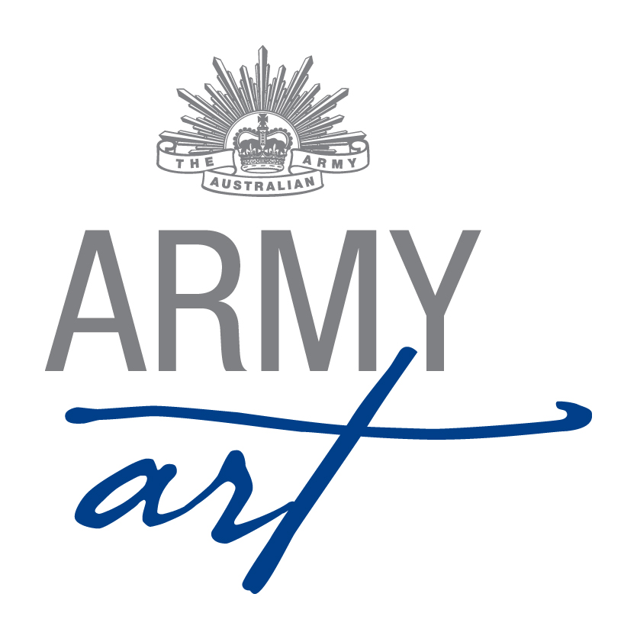
1. Position Duties and Description 2
1.1 Role 2
1.2 Skills Required 2
1.3 Sub Committee/Meetings 2
1.4 General 3
1.5 Sequence of Events 3
Appendix A - Document Control 6
Appendix B - Sample Number of Volunteers 7
Appendix C - Sample Volunteer Flyer 9
Appendix D - Sample Volunteer Contact List 12
Appendix E - Volunteer Advice 13
Appendix F - Sample Thank You and Invitation to attend Function 15
Appendix G - Sample Opening Night Brief for Red Dot Runners 16
Appendix H - Sample Opening Night Name Badges 18

Position Duties and Description
A Committee member should:
- Attend monthly meetings
- Assist with the setting up of the venue (during the day and/or evening)
- Work over acceptance weekend
- Work on Opening Night
- Work over the weekend of the show
- Assist with packing up the venue

Role
The role of the Volunteer Coordinator is to manage the volunteers for the event. This includes:
- Contacting organisations and individuals to recruit volunteers (with the assistance of other Committee members)
- Allocating tasks to volunteers
- Managing the volunteers during the setup, running and packing up of the show
- Make sure that the volunteers adhere to occupational health and safety standards

Skills Required
To fulfil this role the following skills would be useful:
- Good organisational skills
- Approachable and sensitive to the feelings of others
- Good communication and interpersonal skills
- Flexibility
- Eye for detail
- Impartiality
- Fairness
- Respect confidences

Sub Committee/Meetings
- Sub Committees have been formed with the aim of reducing formal meeting times with each subcommittee having the power to make decisions relevant to their area without referral to the Army Art Committee
- The Volunteer Coordinator along with the Painting, Special Exhibits and Venue Coordinators and a member of the Executive form the Display Sub-Committee
- The Volunteer Coordinator along with the Catering and Venue Coordinators and a member of the Executive form the Hospitality Sub-Committee
- Refer to Sub Committee Operational Guidelines for subcommittee meeting and decision requirements

Ensure copies of all formal letters, and relevant memos and emails are forwarded to the Secretary for recording and filing

General
- Any enquiries received are to be referred on to the relevant Coordinator – please do not second guess answers/responses/replies
- Grievances are to be dealt with privately away from the Army Art Venue, volunteers, guests and artists

Sequence of Events

Six Months Prior to Opening Night
Send an email to all volunteers from the previous year advising them the dates of the show. Include the key dates for the show (i.e. dates for setup, Acceptance Day, Opening Night and pack-up).

Three Months Prior to Opening Night
- Discuss with the other Committee members the minimum number of volunteers each is likely to require to successfully run the show
- Advertise for volunteers at i.e.:-
- Private and public schools (meets requirements of the Duke of Edinburgh Award)
- Volunteer WA
- Corporations who encourage community work (i.e. NAB, Rio Tinto)
- Art Schools
- Schools in the Fremantle area
- Seek

Two Months Prior to Opening Night
- Prepare the Request for Volunteers flyer
- Prepare the Volunteer Availability form
- Contact (usually by email) all the previous year’s volunteers and ask if they would like to volunteer again
- Send out Request for Volunteers and Volunteer Availability form to anyone who requests information about volunteering for the show.
NOTE: It is important to establish a good rapport with all the volunteers so they have an enjoyable time throughout the show!!

One Month Prior to Opening Night
- Discuss with Coordinators if they have any volunteers they specifically want to assist them
- As Volunteer Availability forms arrive allocate tasks. Some negotiation may be required to reallocate volunteers to tasks/times they did not list on their forms so all the required tasks are adequately covered
- Produce a name badge (x2) for VIP Guests, Beneficiary Representatives and Sponsorship Representatives (please include logos if applicable) – one badge to Chairperson to send in mail

Three weeks Prior to Opening Night
Confirm with Painting/Special Exhibits Coordinators the number of volunteers available for their respective areas

Two Weeks Prior to Opening Night
- Send a confirmation letter to each volunteer detailing the task/s and time/s they have been allocated and that they will require ID to gain access to Leeuwin Barracks. Include advertising flyer.
- Prepare Volunteer List (Appendix D) detailing tasks/ times/ volunteers/ contact phone numbers to be displayed at the venue each day of set up, the show and pack up. Copies to be provided to all Committee members.
- Ensure there are enough name badge holders for Opening Night
- Produce a name tag for every volunteer who will work on Acceptance Day, Opening Night, Saturday and Sunday of the show and at Pickup. Have a number of name badges with just “Volunteer” so if someone arrives and there is not a name tag for them they can be identified as working for Army Art.
- The name badge should have the Army Art logo in the top middle, the name they wish to be known by in the centre and either Committee or Volunteer at the bottom:

Day Prior to Opening Night
- Set up 20 Red Dot clipboards:
- Sales sheet
- Painting Location Sheet
- Blue pen
- Red dots
- Catalogue
- “Guidelines for Red Dot Runners”

Opening Night
- Lay out name tags where required and in alphabetical order
- Greet volunteers at the door and direct them to where the name tags are located
- Have VIP Guests, Beneficiary Representative and Sponsorship Representative name badges at door in the event they forget to bring badge previously sent by Chairperson
- Brief the Red Dot Volunteers and provide each of them with a clipboard
- At the start of Post Event Supper have all volunteers put their name tags into a basket for the prize draw
- Assist in manning the show in conjunction with the Venue Coordinator

Weekend of Show
- Assist with the manning of the art show venue over the weekend
- Manage the volunteers over the weekend. Discuss any issues with the Chairperson

One Week Post Opening Night
- Send a letter of thanks to all the volunteers with details of the cheque presentation function. Include the photo of volunteers taken on Opening Night (it is a good idea to get someone to take photo with a personal camera as it may take some time to get professional photos back)

Presentation of Cheques Function
- Check the cut-off date for catering and send a reminder email to all volunteers.

For the First Meeting after the Show
Prepare a list of suggestions to improve the show and forward them to the Secretary for discussion at the meeting

One Month Post Opening Night
- Liaise with the Chairperson and update the Volunteer Coordinator’s duty statement.
- Return updated folder to the Chairperson at AGM

Prior to Annual General Meeting
Send list of volunteer email addresses to the Secretary

Document Control
Date | Version | Sections/All | Name | Reason for Change
31/01/2011 | 1 | All | Don Maskew | Initial Document
07/08/2013 | 2 | All | Don Maskew | Changes after 2013 Art Show
21/02/2014 | 3 | All | Secretary | Format and standardisation of Document
20/11/2014 | 4 | 1.3, 1.4, Appendix H | Secretary | Refer Minutes 19th November 2014 – Appendix A

Sample Number of Volunteers
Days to | Week Day | Task | No. | Comments
11 | Monday | Stick dots on floor of drill hall for the placement of screens | 3 | Venue coordinator + 2  Late afternoon
10 | Tuesday | Clean up Drill Hall | 2
 |  | Set up screens – Paintings  Set up screens around wall | 7 | Venue Coordinator + 6
 |  | Assemble lighting | 4 | Bring screwdrivers, shifting spanner, hammer, etc
9 | Wednesday | General Duties | 6
8 | Thursday | Set up ready to receive work | 10
7 | Friday | Receive Paintings | 10 | Painting Coordinator + 9
 |  | Receive Special Exhibits | 3 | Special Exhibits Coordinator + 2
6 | Saturday | Hang Paintings | 10 | Painting Coordinator + 9
 |  | Display Special Exhibits | 3 | Special Exhibits Coordinator + 2
 |  | Proof read catalogue | 2
5 | Sunday | Display Special Exhibits | 6 | Special Exhibits Coordinator + 5
 |  | Hang Paintings | 10 | Painting Coordinator + 9
 |  | Final proof read of catalogue | 2
4 | Monday | Set up Venue | 10
3 | Tuesday | Wash Glasses | 2
 |  | Set up Venue | 10
2 | Wednesday | Iron Tables cloths | 2
 |  | Remove excess equipment from Drill Hall | 5
1 | Thursday | General Duties | 5
0 | Friday | Set up wine area | 4 | Catering Coordinator + 3
 |  | Final set up | 5
0 | Friday | Catering | 16 | In 3 teams – North, South & Beverages
 |  | Door | 4
 |  | Painting Sales Books | 3
 |  | Red Dot Sales | 20 | Hand out catalogues on opening
 |  | Special Exhibits Sales Books | 4
 |  | Treasurer | 1
 |  | Wine | 13
 | Saturday | Special Exhibits Sales Books | 2
 |  | Painting Sales Books | 2
 |  | General Duties | 6
 |  | Wash Glasses | 2
 |  | Tidy up catering areas/café | 4
 | Sunday | Special Exhibits Sales Books | 2
 |  | Painting Sales Books | 2
 |  | General Duties | 6
 |  | Box Glasses | 2
 |  | Pickup – Painting Books | 3
 |  | Pickup – Special Exhibits Books | 2
 |  | Pickup – End of hall | 2 | Guide artists – ask them to wait until person on book is free
 |  | Runners | 24
 | Monday | Pack Away Stores | 10

Sample Volunteer Flyer
I am pleased to announce that Opening Night for Army Art (insert year) will be held on Friday, (insert date) and over the weekend of (insert date) at Leeuwin Barracks, Riverside Road, East Fremantle.
As you would be aware, to run an amazing show and successful fundraiser for West Australian and Defence related charities and philanthropic causes, the dedicated effort of many people is essential.
This year our major beneficiary is:
(Include short brief on the major beneficiary)
WE NEED YOU!!!
As you can see from the attached form we are looking for volunteers to help us host another successful show.
The tasks are very simple and no previous experience is required. You do not need to offer your services for a full day—any time you can give will be very much appreciated.
If you would like to contribute some of your time, please complete and return the attached form to (Volunteer Coordinator) as soon as possible. We will confirm your offer of help prior to (insert date 2 weeks prior to Opening Night).

Name
Volunteer Coordinator
Army Art (year)
Phone: number
Mobile: number
Email: email address
http://armyartwa.blogspot.com.au https://www.facebook.com/#!/ArmyArt2013

Volunteer Enquiries  Volunteer Co-ordinator  Phone:  Email: | General Enquires  Chairperson  Phone:  Email: | Opening Night Ticket Enquiries  Ticket Coordinator  Phone:  Email:
Army Art is supported by Karrakatta Community House Inc.
Name:
Email to:
Or
Post to:
Address:

Phone: Mobile:
Email:
□ Yes I can help (please complete form below) – insert insurance clause here (wording required)
□ I am unable to assist this year however please contact me next year
Time |  | Doing | Skills Needed | Period
To | From
 |  | Set up Screens and Tables | General | Tuesday, date  8:00am – 12:00pm
 |  | Set-up of drill hall | General | Thursday, date  10:00am - 3:00pm
 |  | Acceptance Day | Helping hands and a friendly face | Friday, date  8.30am - 3:00pm
 |  | Assist with set-up of venue and display of work | General - bring your artistic flair | Saturday, date  10:00am - 3:00pm
 |  | As above | General | Sunday, date  10:00am - 3:00pm
 |  | As above | General | Monday, date  10:00am - 2:00pm
 |  | As above | General | Tuesday, date  10:00am - 7:00pm
 |  | As above | General | Wednesday, date  10:00am - 2:00pm
 |  | As above | General | Thursday, date  10:00am - 2:00pm
 |  | Assist with catering | No experience needed – plating up pre-prepared canapés | Friday, date  1:00pm - 4:30pm
 |  | Finishing touches to drill hall | General | Friday, date  9:00am - 12.30pm
 |  | OPENING NIGHT  Food | A friendly face & comfy shoes | Friday, date  4:30pm – 6:00pm
 |  | OPENING NIGHT  Sales Tables | EFTPOS experience if possible | Friday, date  6:00pm – 9.30pm
 |  | OPENING NIGHT  Red Dot person | A friendly face & comfy shoes | Friday, date  6:00pm – 9.30pm
 |  | OPENING NIGHT  Food | A friendly face & comfy shoes | Friday, date  6:00pm – 9.30pm
 |  | OPENING NIGHT  Beverages | A friendly face & comfy shoes  Attainment of Responsible Service of Alcohol | Friday, date  6:00pm – 9:00pm
 |  | Man the Venue | General | Saturday, date  9:00am - 5:00pm
 |  | Man the Venue | General | Sunday, date  10:00am - 4:00pm
 |  | Pickup – Purchasers and Artists pick up work | General | Sunday, date  4:00pm - 8:00pm
 |  | Clean-up and pack away ready for next year | General | Monday, date  9:00am - 2:00pm

Sample Volunteer Contact List

OPENING NIGHT
Surname | Given Name | Mobile | Email Address | Task
BROWN | John | 0428 654 875 |  | Wine/Beverages
JONES | Mary | 0876 756 768 |  | Glass Sales Books
SMITH | Fred | 9876 4563 |  | Red Dot - Painting

Volunteer Advice

Dear (insert name)
Thank you for your offer to assist us with the staging of Army Art (year). Without the assistance of volunteers, such as you, we would not have been able to hold this worthy charitable event for the last 41 years.
This email confirms the times you have offered to volunteer:
Date | From | To | Doing | Skills Needed
Tuesday  (date) | 12.00 noon | 4.00pm | Set up Screens & Tables | General
Friday  (date) | 9.00am | 3.00pm | Acceptance Day | Helping hands & a friendly face
Friday  (date) | 7.00pm | 10.00pm | Opening Night  Glass Sales Book | EFTPOS experience
Please arrive at the main gate of Leeuwin Barracks, Riverside Road, East Fremantle with identification and follow the signs (Army Art) to the Drill Hall where Army Art (year) is being held. NB: if you are unable to produce identification to the guard at the gate you may be denied admittance to the barracks.
Please Note: The task you have been assigned is subject to change according to the circumstances on the day.
If you are now not able to help on the days shown above, or perhaps can offer more of your time, please give me a call on insert number or send an email to insert email.
Endless tea, coffee and friendship will be shared during the event however, if you are volunteering for the whole day, we would suggest you bring something for lunch (alternatively, there is a café located across the road from Leeuwin Barracks).
Opening Night
If you have volunteered to assist on Opening Night we recommend you have a meal before arriving at Leeuwin Barracks as food will not be provided until the show closes at 9.30pm. The Army Art Committee would like to invite you to a Post Event Supper upon doors closing where you will have the opportunity to get together and unwind, enjoy a light supper, sample the wines on offer and toast our success.
As a guideline, the dress requirement on Opening Night is smart casual. Comfortable shoes are an essential part of your attire as most of us will be on our feet all night.
Food
For those who have been given the task of serving food, we ask that you wear black trousers or skirt, and a white top. This will give us a coordinated look and will also assist our catering team leaders in knowing who has been assigned to this position. Catering aprons will be provided. They need to be returned at the end of the evening.
Wine
The volunteers assigned to serving wine will be provided with a T-shirt and an apron supplied by Howling Wolves, makers of our selected wines for the evening. These items will need to be returned at the end of the night. We would ask that your wear a black shirt in the event the T-shirt sizes are not suitable for you.
Cheque Presentation
All volunteers are invited to the Presentation of Cheques Function where the Committee will present funds raised to our major beneficiary, (insert major beneficiary), as well as our minor beneficiaries. The function will be held at Leeuwin Barracks on (insert date) at (insert time). Further details of the event will be emailed to you at the conclusion of Army Art (year) however if you would like to attend please advise the Volunteer Coordinator of your attendance.
Tickets
If you know of anyone who may be interested in tickets to Opening Night please ask them to call the Ticket Coordinator on 0498 574 637. Tickets for Opening Night are $30.00 and are selling fast.
Included with this email is a flyer advertising Army Art (year). We would appreciate you displaying this wherever you may be able to, to assist in promoting the show.
Thank you again for volunteering your time and energy - we look forward to seeing you at Army Art (year).

Insert name
Volunteer Coordinator
Army Art 2015
Mobile: insert number
Email: insert email

http://armyartwa.com.au https://www.facebook.com/#!/ArmyArt2013

Sample Thank You and Invitation to attend Function

Dear (insert name)
Thank you for your volunteering efforts at Army Art (year). I hope you enjoyed yourself!! I believe the success of Army Art is largely due to the efforts of volunteers like you.
We are holding a (insert details of function) to present the beneficiaries their cheques, and we would like to invite you to attend. This is a great opportunity to have a chat with other volunteers, share your experiences and see how your efforts have benefitted our chosen beneficiary. The event will be held at (insert details of where, when and time).
We hope you can attend and ask that you RSVP by (insert date) in order to confirm numbers for catering purposes.

Name
Volunteer Coordinator
Army Art (year)
Phone: number
Mobile: number
Email: email address

http://armyartwa.blogspot.com.au https://www.facebook.com/#!/ArmyArt2013

Sample Opening Night Brief for Red Dot Runners

GUIDELINES FOR RED DOT RUNNERS
Red dot people should move through the crowd or hover a little way away from the sales tables. We don’t want everyone hanging around the sales tables! Approach people who look like they may be going to make a purchase and perhaps discuss it with them.
When a person decides to purchase:
- Write the number of the item on the clip board
- Put a RED DOT on the item (if it is a set of items put a red dot on each).
- Paintings – RED DOTS should be stuck on the items number (NEVER on a painting or the frame!)
- Special Exhibits – RED DOTS should be stuck close to the item’s number, ensuring the number can still be read. Ensure that if all items of a set are purchased that all pieces are dotted.
- Accompany the person to the sales table, hand-over and then start circulating again.
If a person approaches the sales table and a sales table person calls you:
- Write the number on the clip board
- Ask the purchaser the location and description of the item (also use the “mud map” to locate the painting). If you can’t locate the item, go back to the purchaser and ask them to show you where it is located.
- Locate the item and put a RED DOT on it (if it is a set of items put a red dot on each).
- Paintings – RED DOTS should be stuck on the items number (NEVER on a painting or the frame!)
- Special Exhibits– RED DOTS should be stuck close to the items number, ensuring the number can still be read. Ensure that if all items of a set are purchased that all pieces are dotted.
- Start circulating again.
Catalogue Item Number
The numbers in the catalogue may be missing a number here and there, this is caused by artists withdrawing items after the numbers have been allocated.
Post Event Supper
A light supper and drinks will be available for all volunteers once all guests have left and doors are closed.

Name Badges
Please wear your name badge prominently during the night. Upon doors closing please return the badge to the basket for your chance to win a prize at the Post Event Supper.

THANK YOU VERY MUCH FOR YOUR SUPPORT!

Sample Opening Night Name Badges
Full Name  Special Guest | Name  Position  2015 Army Art
Logo  Full Name  Major Sponsor | Pam  Volunteer
Logo  Full Name  Sponsor | Joanne  Volunteer
Logo

Full Name
Major Beneficiary

